Elton, Gruber, Brown, and Goetzmann
Modern Portfolio Theory and Investment Analysis, 9th Edition
Solutions to Text Problems: Chapter 15

Chapter 15: Problem 1

That is NOT a valid test of the theory, and the empirical evidence IS consistent with the theory. If high-beta stocks always gave higher returns, then they would be less risky than low-beta stocks. It is precisely because the returns on high-beta stocks are more risky, and hence sometimes below and sometimes above the returns on low-beta stocks, that high-beta stocks have higher expected (and over long periods of time higher actual) returns.

Chapter 15: Problem 2

Let:
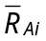 = the expected percentage change in alcoholism in city i;
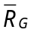 = the expected percentage change in the price of gold;
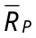 = the expected percentage change in professors’ salaries.

Then we have:

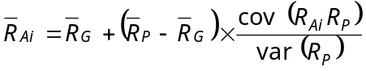

The above equation is exactly parallel to the zero-beta CAPM equation, with expected percentage change in alcoholism in a city playing the role of the expected return on a security. The analogy between variables is seen from:

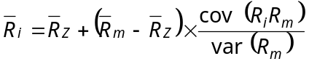

Therefore, tests exactly parallel to those employed in the text can be used.

Chapter 15: Problem 3

Since the equality shown in equation (15.7) in the text only holds for an efficient portfolio, if the market portfolio is inefficient the equality will not hold and instead we have:
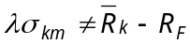

The remaining proof follows the proof shown in the text below equation (15.7), but with the not-equal sign replacing the equal sign in all the remaining equations in the proof.

Chapter 15: Problem 4

One way to use general equilibrium theory to evaluate a stock portfolio manager’s performance would be to estimate the equilibrium security market line using historical time series of returns over a period of time along with the portfolio’s average return and beta. If, given the portfolio’s beta, the portfolio had an average return above the equilibrium return predicted by the estimated security market line, it would indicate superior performance. (This performance measure is known as “Jensen’s alpha” and is discussed at length in Chapter 24.)

Chapter 15: Problem 5

If the post-tax form of the CAPM holds, then the real relationship as a cross-sectional regression model is:

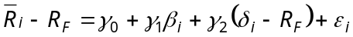

If the standard CAPM security market line is tested, the cross-sectional regression model is:
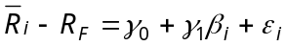

If δ was uncorrelated with β across securities, then the regression estimates of
γ₀ and γ₁ in the standard model would be unaffected. However, empirical evidence shows that δ and β are negatively correlated across securities (high-dividend securities tend to have low betas and low-dividend securities tend to have high betas) and that δ is positively correlated with across securities, so this is a classic case of missing-variable bias. The effect of the bias is to raise the estimate of the intercept (γ₀) and lower the estimate of the slope (γ₁).

